1.INTRODUCTION

1.1 OVERVIEW

Chronic kidney disease (CKD) prediction project involves developing a machine learning model that can accurately predict the likelihood of an individual developing CKD based on certain input parameters such as age, sex, blood pressure, blood sugar levels, and other relevant medical history. The project aims to use historical patient data to identify key risk factors for CKD and build a predictive model that can be used to screen individuals at risk of developing the disease. The ultimate goal of this project is to improve early detection and management of CKD, leading to better health outcomes for patients.

1.2 PURPOSE

The use of CKD prediction projects:

1.Early detection:

By predicting the likelihood of developing CKD, individuals can be identified early, and measures can be taken to prevent or slow down the progression of the disease.

2.Improved healthcare planning:

Healthcare professionals can use CKD prediction models to identify high-risk patients and plan for appropriate medical interventions and treatments.

3.Cost-effective care:

identification and prevention of CKD can help reduce the burden on healthcare systems and avoid the high cost of treating advanced stages of the disease.

4.Personalized treatment plans:

CKD prediction models can provide insights into individual risk factors, allowing for personalized treatment plans to be developed for each patient.

5.Better patient outcomes:

Early detection and prevention of CKD can lead to improved patient outcomes, including better quality of life, reduced mortality rates, and lower healthcare costs.

In summary, CKD prediction projects have the potential to improve patient outcomes, reduce healthcare costs, and improve healthcare planning by identifying high-risk patients and developing personalized treatment plans.

Achievements:

* Improved patient outcomes
* Less healthcare costs
* Facilitated personalized treatment plans

2.PROBLEM DEFINITION AND DESIGN THINKING

PROBLEM DEFINITION

CKD (Chronic Kidney Disease) prediction project aims to develop a predictive model that can identify individuals who are at risk of developing CKD. Chronic Kidney Disease is a medical condition in which the kidneys gradually lose their function over time. Early detection and treatment of CKD can slow down its progression, prevent complications, and improve health outcomes.

The project involves collecting relevant data such as demographics, medical history, laboratory results, and lifestyle factors from a population of individuals. This data is then used to train a machine learning model to identify patterns and associations between the risk factors and the occurrence of CKD.

The predictive model can then be used to screen individuals for CKD risk and recommend appropriate interventions such as lifestyle changes, medication, and referral to a nephrologist for further evaluation and treatment. The goal of this project is to improve early detection and management of CKD, ultimately leading to better health outcomes for individuals at risk of developing this condition.

DECISION THINKING

1.Define the problem:

The problem is to develop a predictive model that can identify individuals who are at risk of developing CKD.

2.Gather data:

Relevant data such as demographics, medical history, laboratory results, and lifestyle factors should be collected from a population of individuals.

3.Data pre-processing:

The collected data needs to be pre-processed to remove missing values, outliers, and other inconsistencies that could affect the accuracy of the predictive model.

4.Feature selection:

Features that are most predictive of CKD should be selected from the pre-processed data.

5.Model selection:

Different machine learning algorithms should be evaluated to determine the one that produces the most accurate predictions.

6.Model training:

The selected machine learning algorithm should be trained on the pre-processed data.

7.Model validation:

The trained model should be tested on a validation set of data to ensure that it is accurate and generalizable.

8.Deployment:

The validated model should be deployed in a clinical setting to screen individuals for CKD risk and recommend appropriate interventions.

9.Monitoring:

The model's performance should be monitored over time to ensure that it continues to produce accurate predictions.

10.Continuous improvement:

The model should be updated and improved over time as new data becomes available and as new machine learning techniques are developed.

Through this decision thinking process, the CKD prediction project can produce a reliable predictive model that can help improve early detection and management of CKD, ultimately leading to better health outcomes for individuals at risk of developing this condition.

2.1 EMPATHY MAP

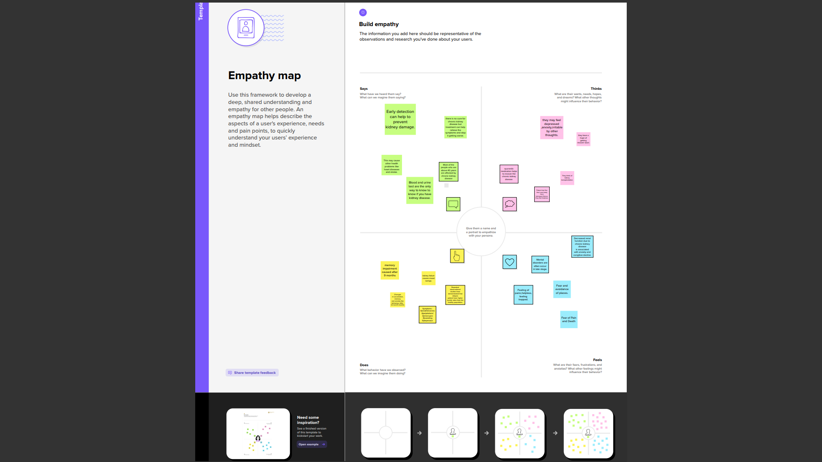

2.2 IDEATION AND BRAINSTORMING MAP

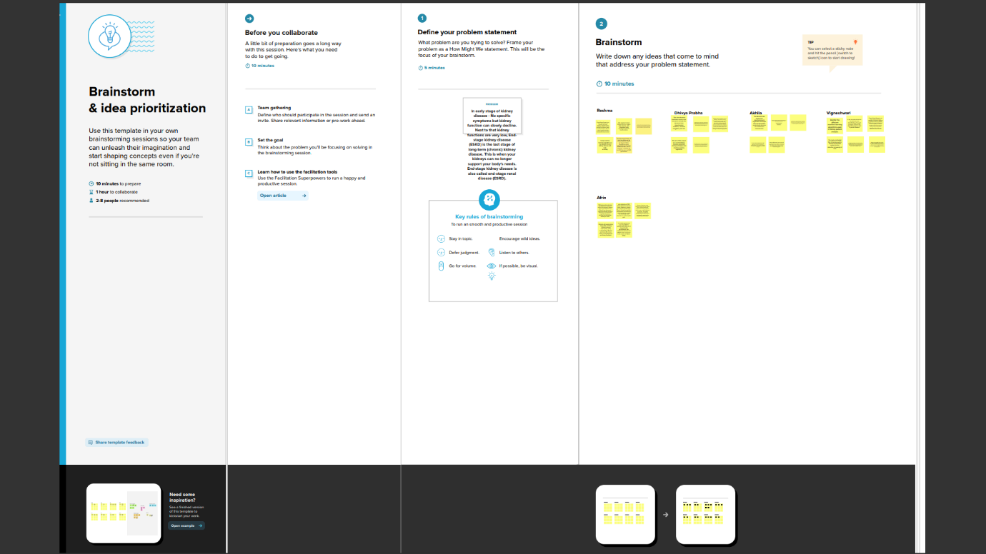

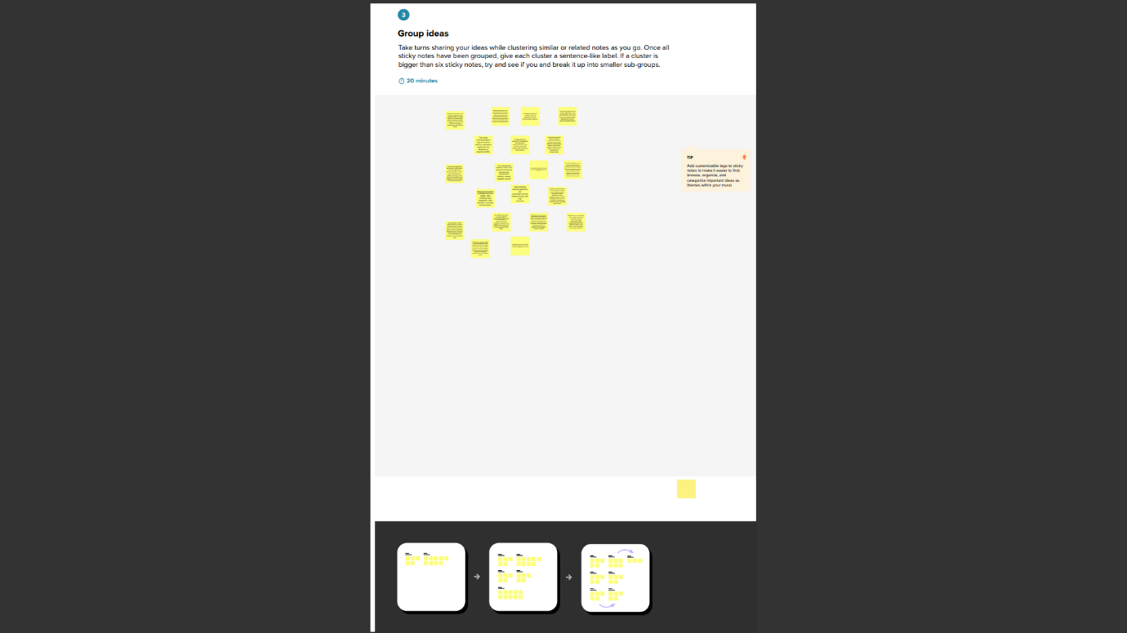

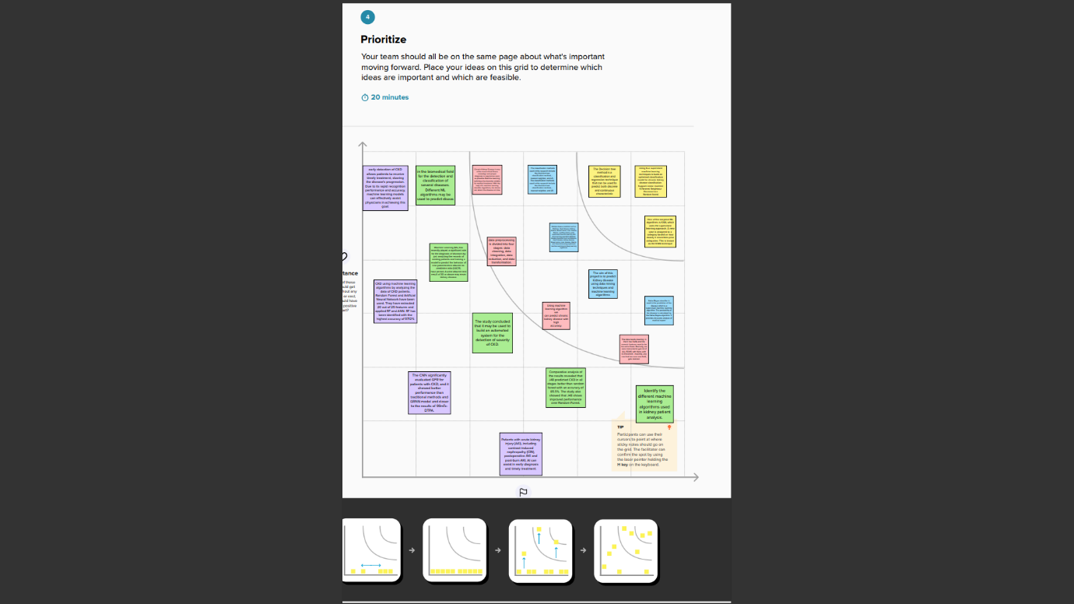

3.RESULT

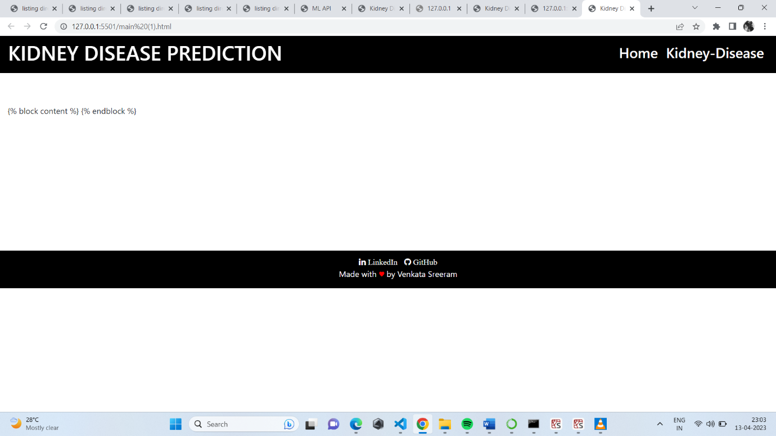

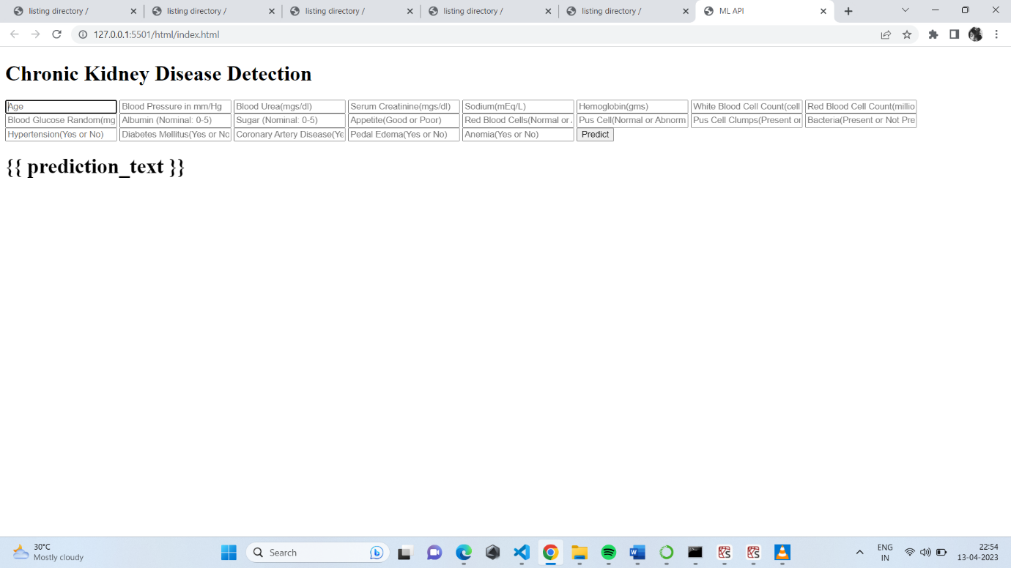

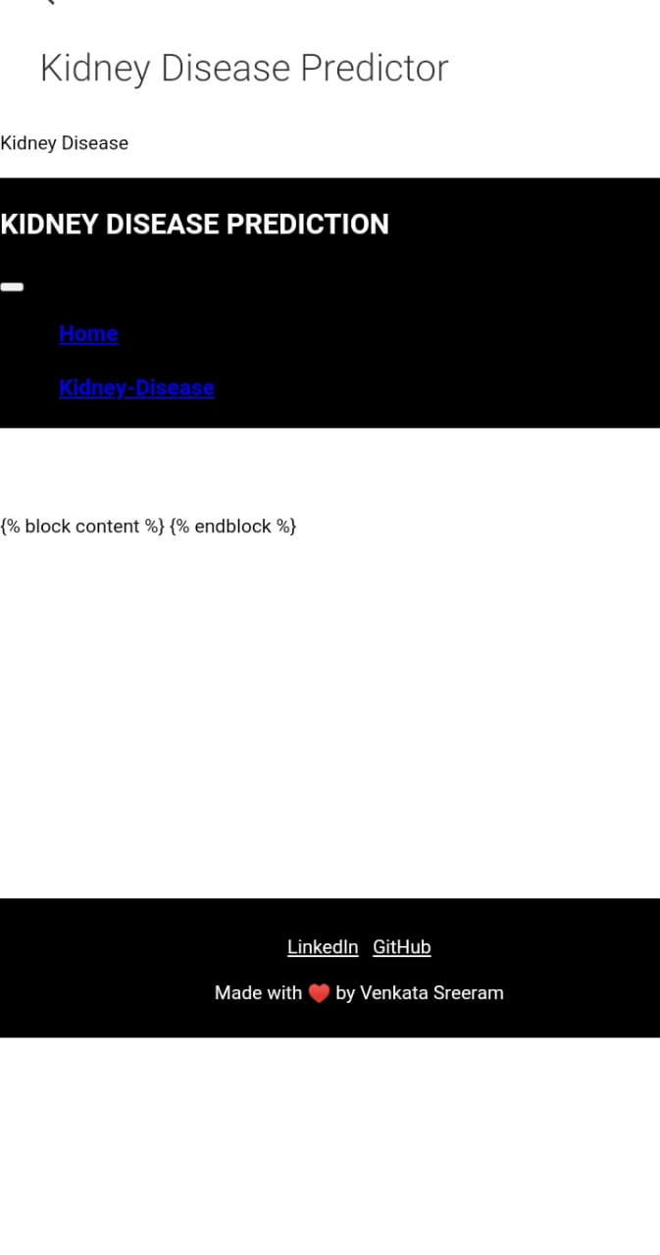

4.ADVANTAGES AND DISADVANTAGES OF PROPOSED SYSTEM

4.1 ADVANTAGES

1.Early detection

2.Improved patient outcomes

3.Personalized treatment

4.Cost-effective

5.Research and Development

1.Early detection:

The main advantage of a CKD prediction project is that it can detect the disease at an early stage. This allows for early intervention and treatment, which can slow or even prevent the progression of the disease.

2.Improved patient outcomes:

Early detection and intervention can lead to better patient outcomes, including improved quality of life and reduced healthcare costs.

3.Personalized treatment:

A CKD prediction model can provide personalized treatment plans for patients based on their risk factors, medical history, and other factors. This can help optimize treatment and improve outcomes.

4.Cost-effective:

CKD is a costly disease to manage, and early detection and intervention can help reduce costs. By identifying patients at high risk of CKD, healthcare providers can focus resources on those who need it most.

5.Research and development:

A CKD prediction project can also provide valuable data for research and development of new treatments and interventions for CKD.

4.2 DISADVANTAGE

One potential disadvantage of a chronic kidney disease (CKD) prediction project using machine learning is the risk of bias in the dataset used to train the model. If the dataset is not representative of the population at large, the model may not perform well on new data or may produce biased predictions. For example, if the dataset is skewed towards a particular age group or ethnic group, the model may not accurately predict CKD risk for individuals outside of that group

The lack of interpretability of the model. Machine learning models can be very complex, and it may be difficult to understand how the model is making its predictions. This can be a concern in healthcare, where decisions based on predictions can have significant consequences.

Overfitting, which occurs when a model is too complex and performs well on the training data but poorly on new data. Overfitting can be especially problematic in CKD prediction projects, where the consequences of inaccurate predictions can be serious.

Finally, there may be issues related to data privacy and security. Patient data is sensitive information, and steps must be taken to protect it from unauthorized access or disclosure. The use of machine learning models in healthcare requires careful consideration of these privacy and security concerns.

5.APPLICATION

APPLICATION USED IN SECTORS LIKE

1.Clinical settings

2.Public health

3.Personal health care

4.Research

5.Telemedicine

1.Clinical settings:

The system can be integrated into clinical settings such as hospitals, clinics, and doctor's offices to assist physicians in the early diagnosis and management of CKD.

2.Public health:

system can be used in public health initiatives to screen high-risk individuals for CKD and to monitor the prevalence and incidence of CKD in the general population.

3.Personal healthcare:

The system can be used by individuals to monitor their risk of developing CKD, especially those with a family history or other risk factors, such as hypertension or diabetes.

4.Research:

The system can be used in research to identify risk factors for CKD and to develop new treatments and preventive measures.

5.Telemedicine:

The system can be used in telemedicine to provide remote consultations and monitoring of patients with CKD.

Overall, the CKD prediction project using machine learning can be applied in a wide range of settings to improve the early detection and management of CKD, leading to better patient outcomes and reduced healthcare costs.

6.CONCLUSON

In conclusion, the proposed system for Chronic Kidney Disease (CKD) prediction using machine learning has the potential to significantly improve the diagnosis and management of CKD. By analysing large amounts of data quickly and accurately, the system can detect CKD in its early stages, allowing for early intervention and management. The use of machine learning algorithms can improve the accuracy of CKD prediction and can be personalized to the individual patient, taking into account their medical history, lifestyle, and other factors. This personalized approach can lead to better treatment outcomes and reduce healthcare costs. Overall, the implementation of a machine learning-based CKD prediction system has the potential to improve patient outcomes and reduce the burden of CKD on healthcare systems.

**7.FUTURE SCOPE**

The future scope of the CKD prediction project using machine learning

* To improve the accuracy and Speed
* Personalization of CKD diagnosis and management
* Expand to other chronic diseases
* Leading to better patient outcomes
* Reduced healthcare costs.

1.Improvement of accuracy:

Machine learning algorithms are highly accurate in predicting CKD, further improvements in accuracy can be made by incorporating more patient-specific data, such as genetics and lifestyle factors.

2.Integration with electronic health records (EHRs):

Integration of the CKD prediction system with EHRs can improve the accuracy and speed of diagnosis and allow for personalized treatment.

3.Integration with wearable devices:

Integration of the CKD prediction system with wearable devices, such as smartwatches or fitness trackers, can provide continuous monitoring of CKD risk factors and early detection of CKD.

4.Development of personalized treatment plans:

The use of machine learning can help in developing personalized treatment plans based on patient-specific data, including medical history, genetics, and lifestyle factors.

5.Expansion to other chronic diseases:

The machine learning-based CKD prediction system can be expanded to predict other chronic diseases, such as cardiovascular disease or diabetes, by incorporating relevant risk factors into the algorithm.

6.Global implementation:

The CKD prediction project can be implemented on a global scale, especially in developing countries, where the burden of CKD is high but resources for diagnosis and treatment are limited.

8. APPENDIX

1. Source code

